 **NATIONAL INSTITUTE OF TECHNOLOGY**

**(An Institute of National Importance)**

**WARANGAL**

**TELANGANA, 506004**

DATABASE MANAGEMENT SYSTEM PROJECT REPORT

ON

**HOSTEL MANAGEMENT SYSTEM**

By

**KAMMULA KEERTHI**

**22EEB0B21**

Department of Electrical and Electronics Engineering

**PROBLEM STATEMENT:**

In this project, I have designed a database management system to store and manage the information about a student's details, Hostel allotment and Complaint management. The Database contains important information about the students Hostel allotment and issues faced by students in hostels. This Database contains the students' details, hostel allotment details, hostel and room details, payment details, worker details and complaints filed by students. This Database will help the students and officials during the Room allotment process and let them know about the complaint status i.e., whether the complaint raised by student is resolved or not.

**ASSUMPTONS:**

1. One Student can be allotted only one room.
2. A hostel is completely for male or completely for female.
3. Multiple Hostels can have same Room number.
4. One Worker can simultaneously work on many queries.
5. One student can launch any number of complaints.

**TABLES:**

**Students:**

|  |  |  |
| --- | --- | --- |
| **Attributes** | **Datatypes** | **Constraints** |
| Stu_roll_no | Varchar(9) | Primary key |
| Stu_name | Varchar(45) | NOT NULL |
| Stu_dept | Varchar(10) | NOT NULL |
| Stu_ph_no | Varchar(10) | Unique |
| Email | Varchar(45) | Unique |
| Gender | Varchar(6) | NOT NULL |
| Stu_year | Int | NOT NULL |
| Password | Varchar(20) | NOT NULL |

**Hostel:**

|  |  |  |
| --- | --- | --- |
| **Attributes** | **Datatypes** | **Constraints** |
| Hostel_id | Varchar(10) | Primary key |
| Hostel_name | Varchar(10) | NOT NULL |
| Rooms_capacity | Int | NOT NULL |
| Annual fee | Int | NOT NULL |
| Gender | Varchar(5) | NOT NULL |

**Room:**

|  |  |  |
| --- | --- | --- |
| **Attributes** | **Datatypes** | **Constraints** |
| Room_no | Varchar(6) | Primary key |
| Hostel_id | Varchar(10) |
| Capacity | Int | NOT NULL |
| Status | bool | NOT NULL |

**Work:**

|  |  |  |
| --- | --- | --- |
| **Attributes** | **Datatypes** | **Constraints** |
| Work_dept_id | Varchar(10) | Primary key |
| Dept_name | Varchar(10) | NOT NULL |

**Workers:**

|  |  |  |
| --- | --- | --- |
| **Attributes** | **Datatypes** | **Constraints** |
| Worker_id | Varchar(10) | Primary key |
| Worker_name | Varchar(30) | NOT NULL |
| Worker_ph_no | Varchar(10) | Unique |
| Work_dept_id | Varchar(10) | Foreign key |
| Active | Bool | NOT NULL |
| Complaints_resolved | Int | NOT NULL |

**Mess:**

|  |  |  |
| --- | --- | --- |
| **Attributes** | **Datatypes** | **Constraints** |
| Mess_id | Varchar(10) | Primary key |
| Mess_name | Varchar(15) | NOT NULL |
| Per_day_cost | Int | NOT NULL |
| Mess_incharge | Varchar(10) | NOT NULL |
| Contractor | Varchar(15) | NOT NULL |

**Allotment:**

|  |  |  |
| --- | --- | --- |
| **Attributes** | **Datatypes** | **Constraints** |
| Payment_id | Varchar(10) | Primary key |
| Payment_amount | Int | NOT NULL |
| Payment_date | Date | NOT NULL |
| Hostel_id | Varchar(10) | Foreign key |
| Room_no | Varchar(6) | Foreign key |
| Stu_roll_no | Varchar(9) | Foreign key |
| Mess_id | Varchar(15) | Foreign key |

**Complaints:**

|  |  |  |
| --- | --- | --- |
| **Attributes** | **Datatypes** | **Constraints** |
| Complaint_id | Varchar(10) | Primary key |
| Stu_roll_no | Varchar(9) | Foreign key |
| Work_dept_id | Varchar(10) | Foreign key |
| Room_no | Varchar(6) | Foreign key |
| Hostel_id | Varchar(10) | Foreign key |
| Complaint | Varchar(100) | NOT NULL |
| Worker_id | Varchar(10) | Foreign key |
| Resolved | bool | NOT NULL |

**FUNCTIONAL DEPENDENCIES AND PRIMARY KEY:**

**1.Students:**

Stu_roll_no {Stu_name, Stu_dept, Stu_ph_no, Email, Gender, Stu_year, Password}

Since all the fields depend on Stu_roll_no, (Stu_roll_no) R.

Hence, Stu_roll_no is a primary key.

**2.Hostel:**

Hostel_id { Hostel_name, Rooms_capcity, Annual_fee, Gender}

Since all the fields depend on Hostel_id, (Hostel_id) R.

Hence, Hostel_id is a primary key.

**3.Room:**

(Room_no, Hostel_id) {capacity, Status}

Since all the fields depend on (Room_no, Hostel_id), (Room_no, Hostel_id) R.

Hence, (Room_no, Hostel_id) is a primary key.

**4.Work:**

Work_dept_id {dept_name}

Since all the fields depend on Work_dept_id, (Work_dept_id) R.

Hence, Work_dept_id is a primary key.

**5.Workers:**

Worker_id {Worker_name, Worker_ph_no, Work_dept_id, Active, Complaints_resolved}

Since all the fields depend on Worker_id, (Worker_id) R.

Hence, Worker_id is a primary key.

**6.Mess:**

Mess_id {Mess_name, Per_day_cost, Mess_incharge, Contractor}

Since all the fields depend on Mess_id, (Mess_id) R.

Hence, Mess_id is a primary key.

**7.Allotment:**

Payment_id {Payment_amount, Payment_date, Hostel_id, Room_no, Stu_roll_no, Mess_id}

Since all the fields depend on Payment_id, (Payment_id) R.

Hence, Payment_id is a primary key.

**8.Complaints:**

{Complaint_id} {Stu_roll_no, Work_dept_id, Room_no, Hostel_id, Complaint, Worker_id, Resolved}

Since all the fields depend on (Complaint_id) R.

Hence, (Complaint_id) is a primary key.

**NORMALISATION:**

1. **Student:**

Primary key: Stu_roll_no

All attributes depend on the Stu_roll_no, hence the table is in 2NF.

All attributes depend directly on Stu_roll_no, hence the table is in 3NF.

All determinants (Stu_roll_no) is Super key, hence the table is in BCNF.

1. **Hostel:**

Primary key: Hostel_id

All attributes depend on the Hostel_id, hence the table is in 2NF.

All attributes depend directly on Hostel_id, hence the table is in 3NF.

All determinants (Hostel_id) is Super key, hence the table is in BCNF.

1. **Room:**

Primary key: Room_no

All attributes depend on the Room_no, hence the table is in 2NF.

All attributes depend directly on Room_no, hence the table is in 3NF.

All determinants (Room_no) is Super key, hence the table is in BCNF.

1. **Work:**

Primary key: Work_dept_id

All attributes depend on the Work_dept_id, hence the table is in 2NF.

All attributes depend directly on Work_dept_id, hence the table is in 3NF.

All determinants (Work_dept_id) is Super key, hence the table is in BCNF.

1. **Workers:**

Primary key: Worker_id

All attributes depend on the Worker_id, hence the table is in 2NF.

All attributes depend directly on Worker_id, hence the table is in 3NF.

All determinants (Worker_id) is Super key, hence the table is in BCNF.

1. **Mess:**

Primary key: Mess_id

All attributes depend on the Mess_id, hence the table is in 2NF.

All attributes depend directly on Mess_id, hence the table is in 3NF.

All determinants (Mess_id) is Super key, hence the table is in BCNF.

1. **Allotment:**

Primary key: Payment_id

All attributes depend on the Payment_id, hence the table is in 2NF.

All attributes depend directly on Payment_id, hence the table is in 3NF.

All determinants (Payment_id) is Super key, hence the table is in BCNF.

1. **Complaints:**

Primary key: Complaint_id

All attributes depend on the Complaint_id, hence the table is in 2NF.

All attributes depend directly on Complaint_id, hence the table is in 3NF.

All determinants (Complaint_id) is Super key, hence the table is in BCNF.

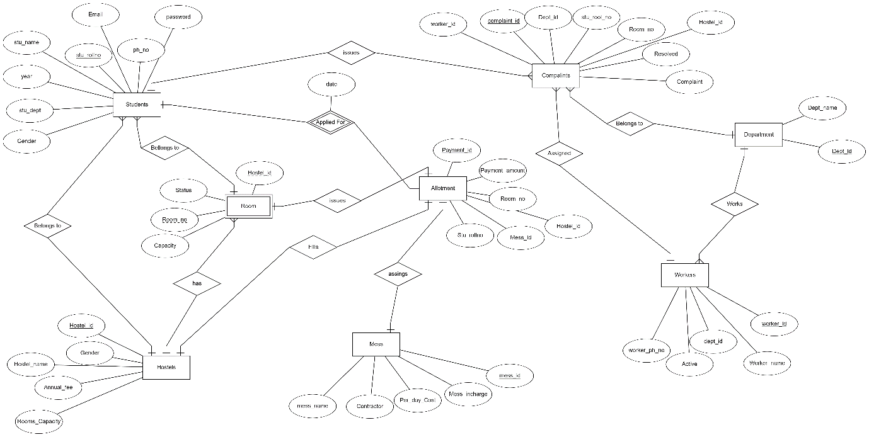**ER DIAGRAM:**

**RELATIONAL SCHEMA:**

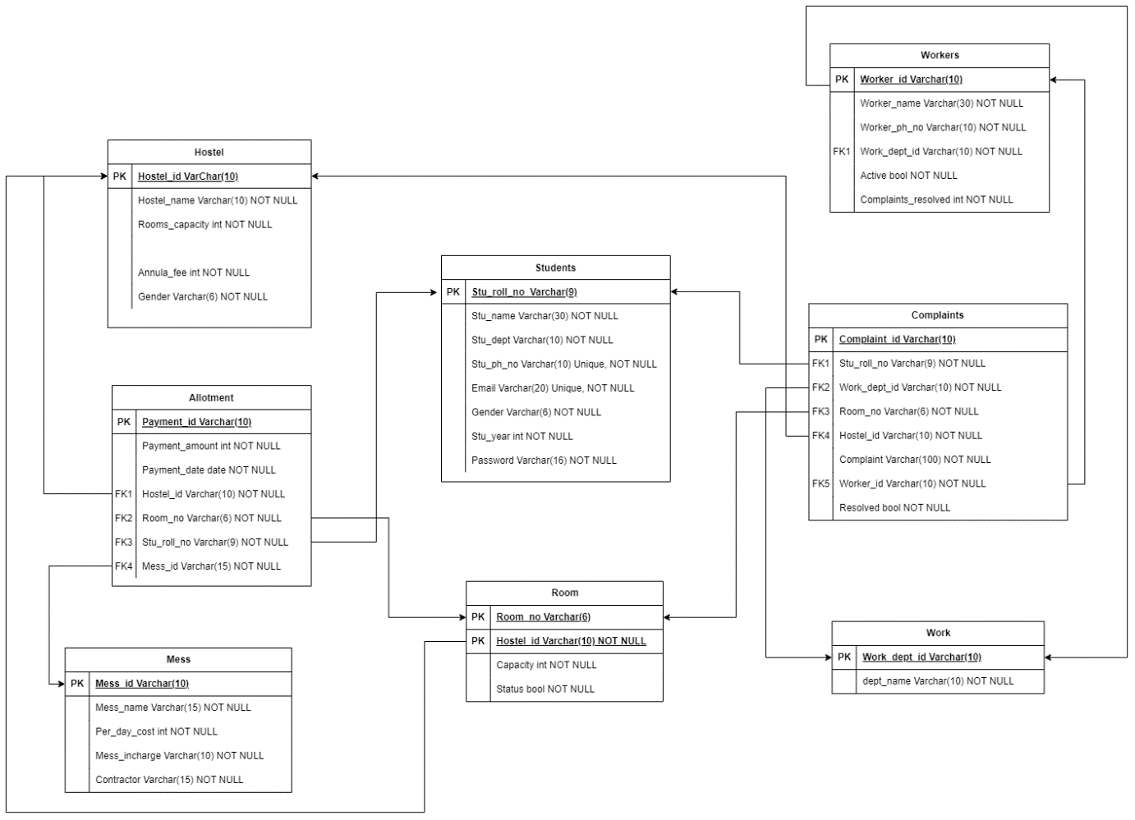

**MYSQL CODES:**

**Creating Tables:**



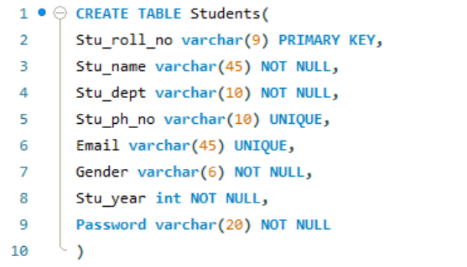

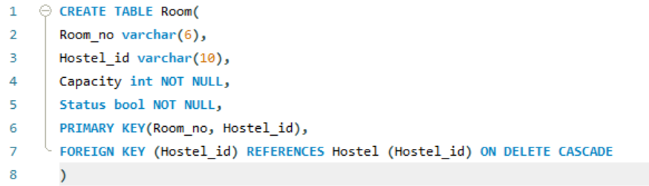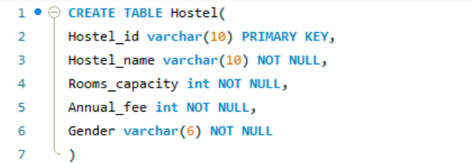

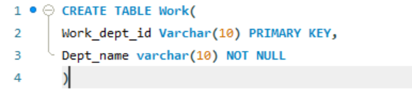

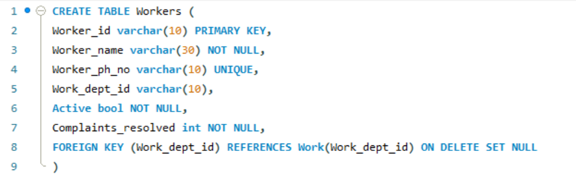

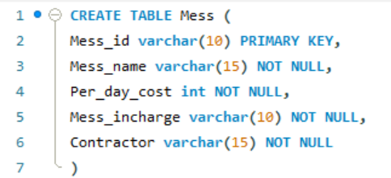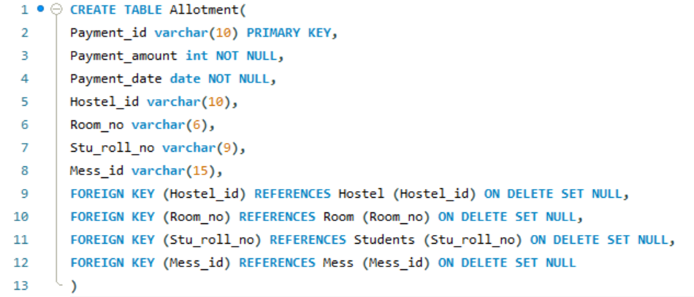

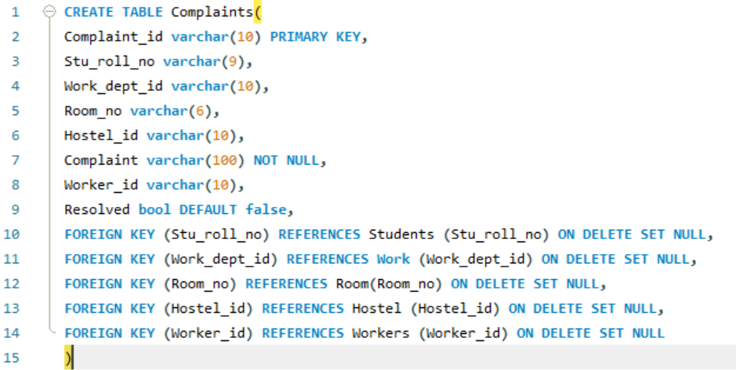

**- Check if all tables are created**



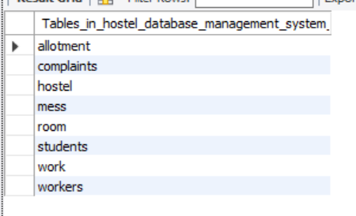

**INSERTING DATA:**

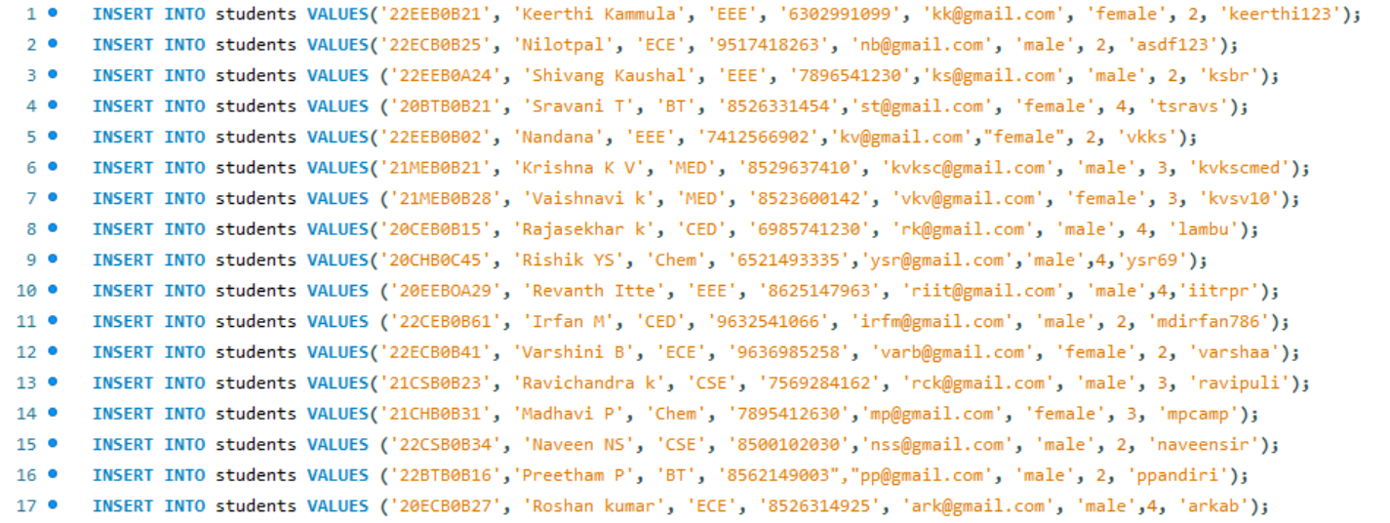

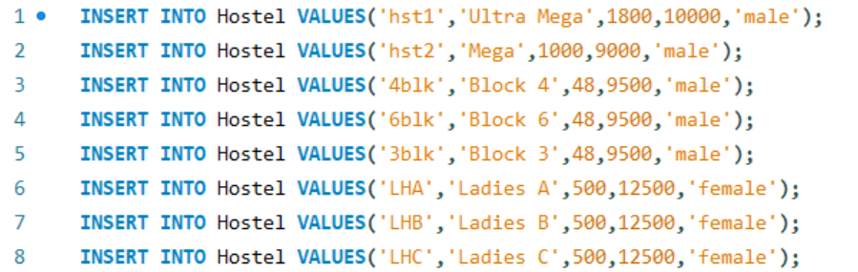

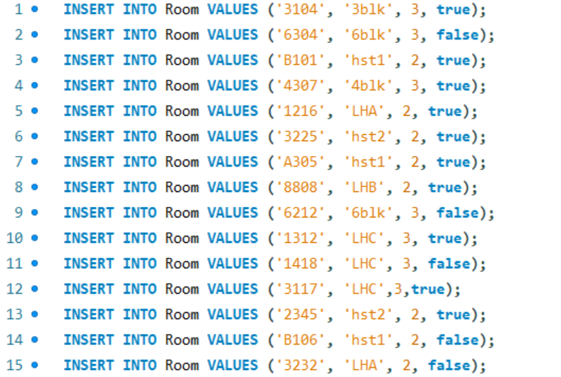

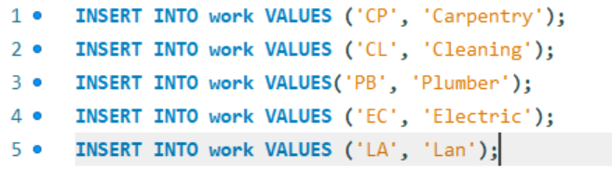

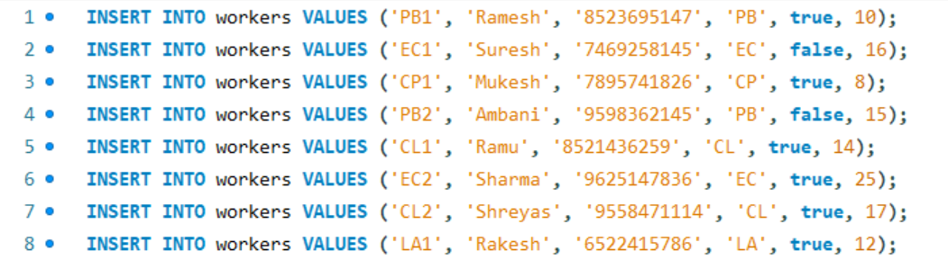

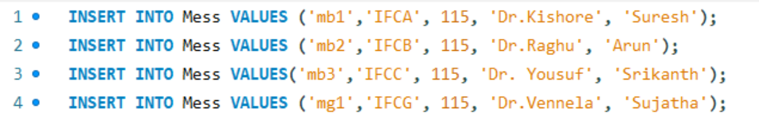

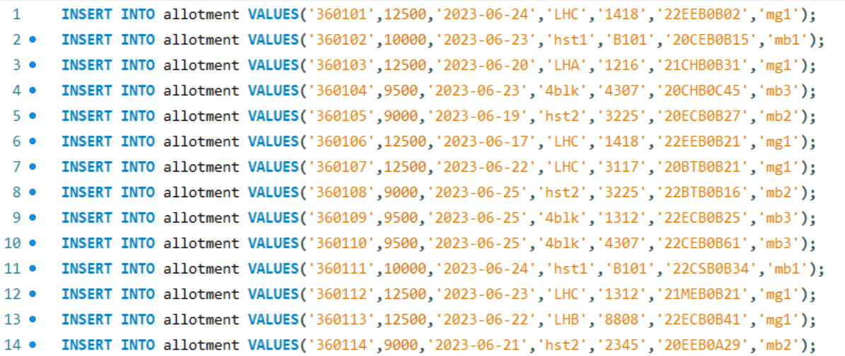

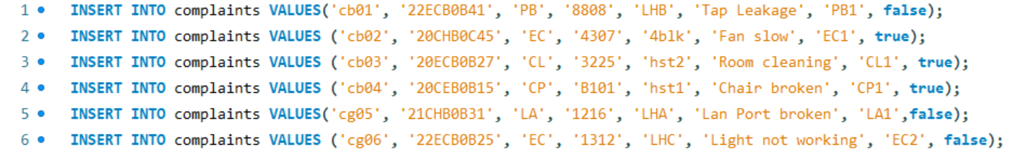

**TABLES:**

1. **Students:**

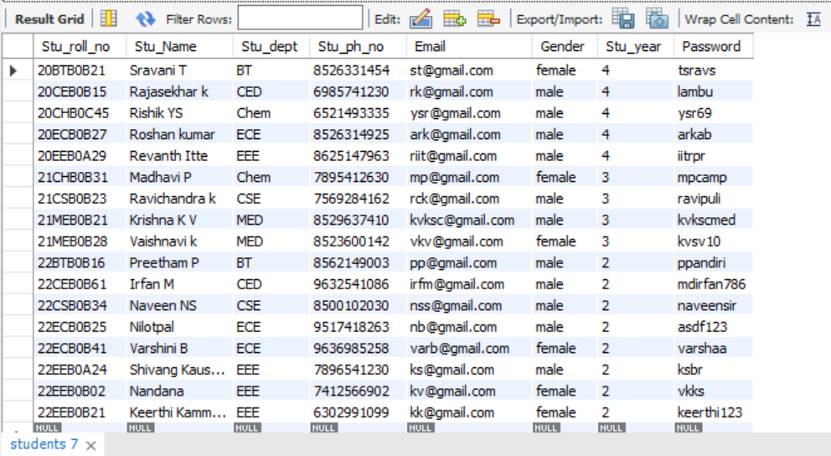

1. **Hostel:**

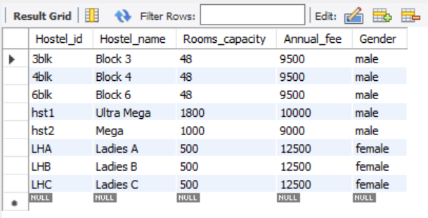

1. **Room:**

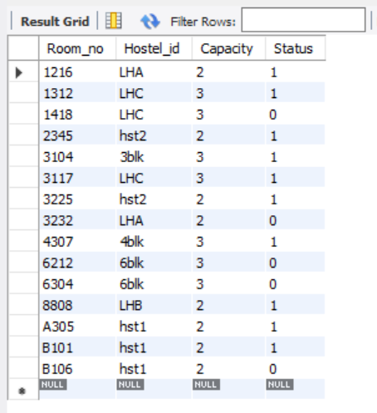

1. **Work:**

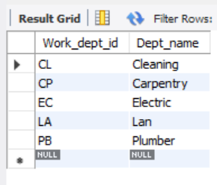

1. **Workers:**

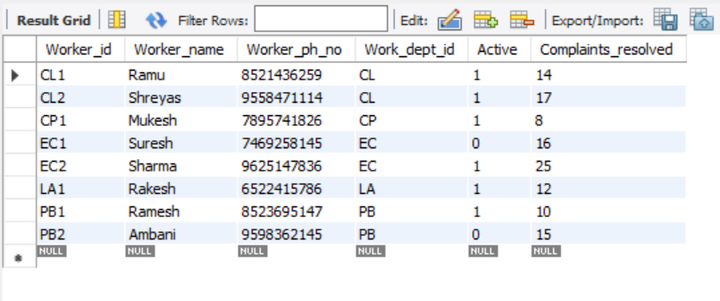

1. **Mess:**

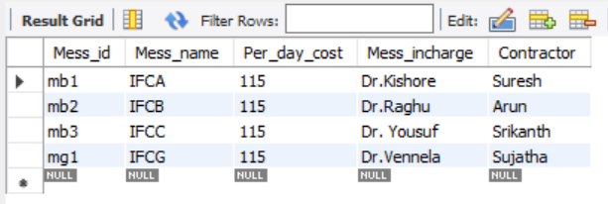

1. **Allotment:**

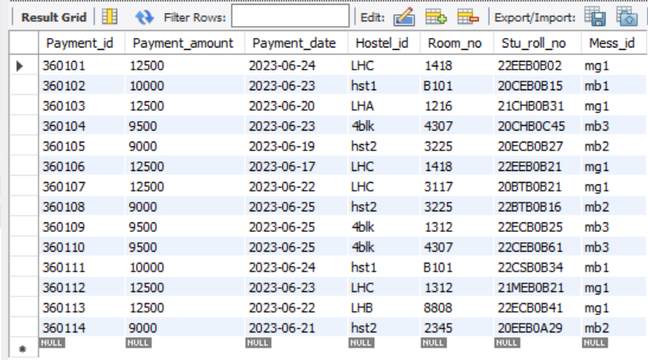

1. **Complaints:**

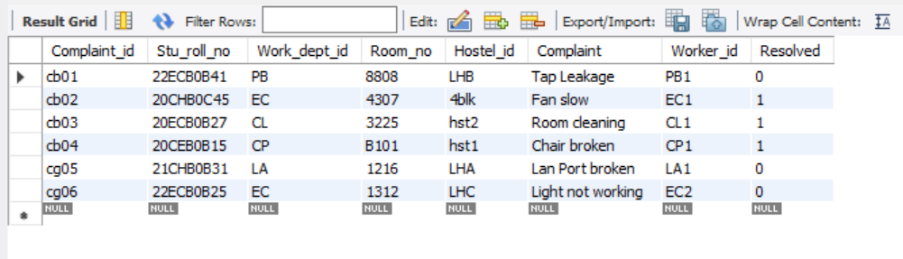

**QUERIES:**

1. Display all vacant rooms.



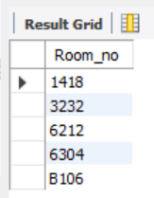

1. Display all the workers’ names who have pending queries.



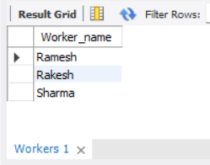

1. Display the complaints raised by the student named ‘Roshan kumar’.



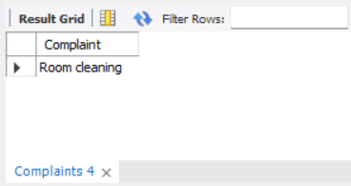

1. Display the names of all the students who have not been allotted any room.



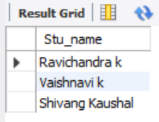

1. Display the names of the students who were allotted the room ‘1418’.



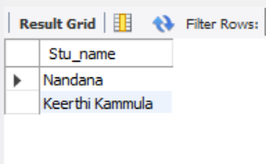

**THANK YOU**

GitHub link: https://github.com/Keerthi29062005/Hostel-DBMS-project/tree/main